**[Manshuk Mametova](http://en.wikipedia.org/wiki/Manshuk_Mametova" \o "Manshuk Mametova" \t "_blank)**

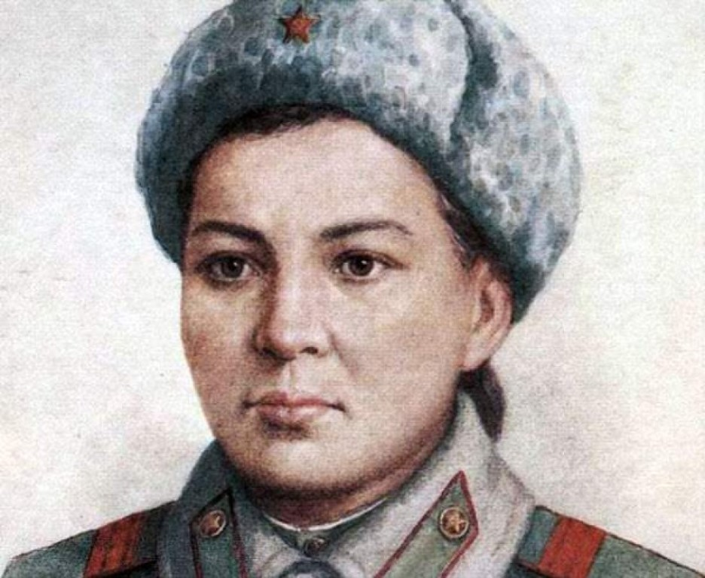

**Mariya Oktyabrskaya**

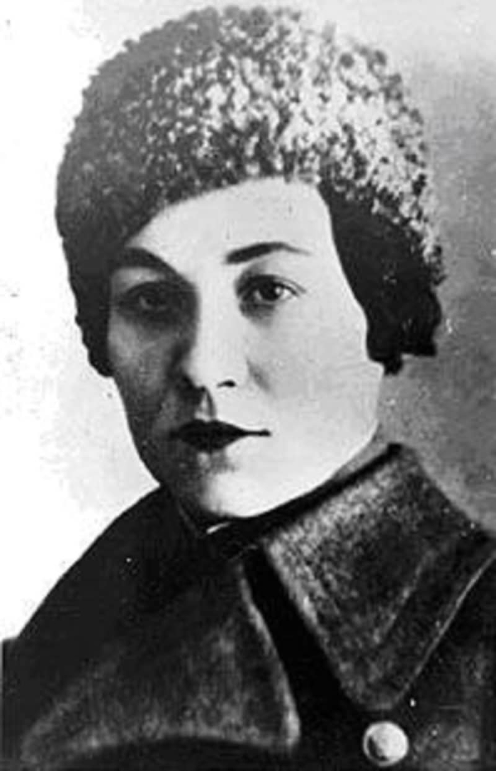

**Marina Raskova**

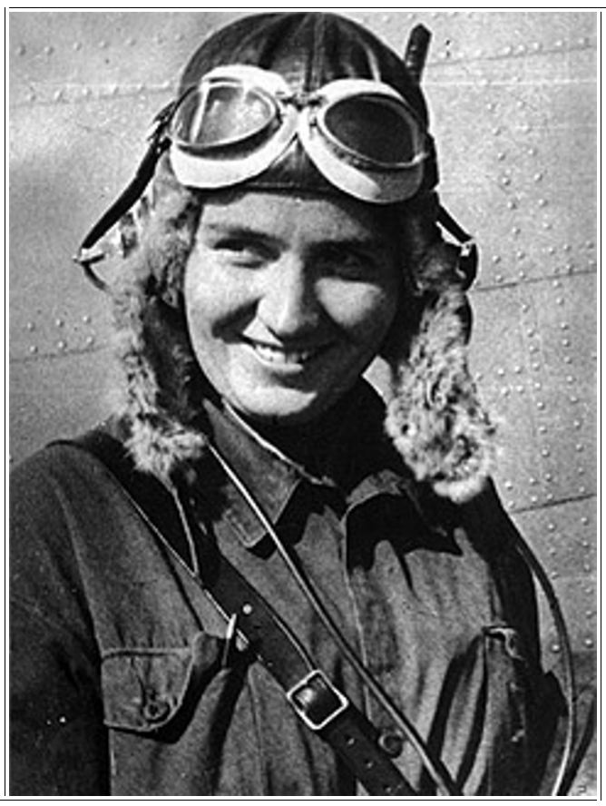

**Lydia Litvyak**

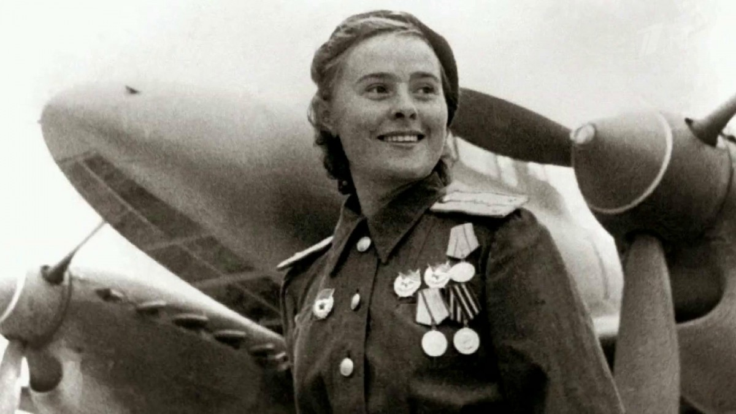

[**Lyudmila Pavlichenko**](http://en.wikipedia.org/wiki/Lyudmila_Pavlichenko)

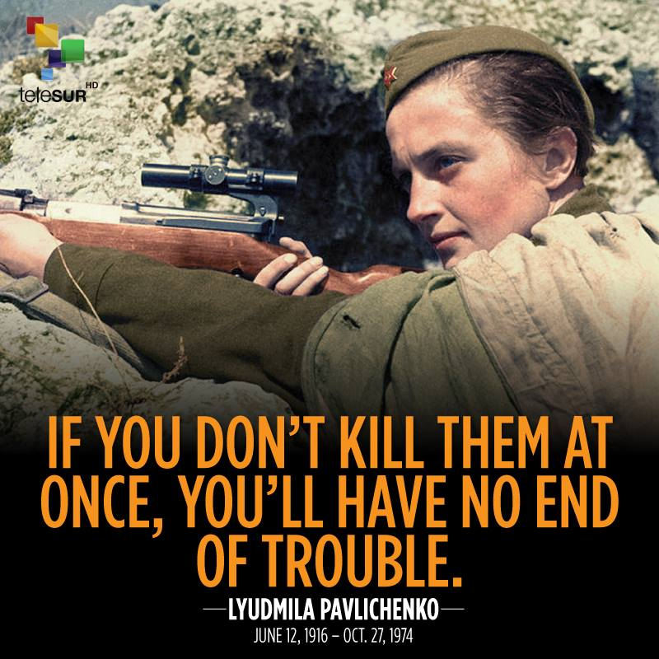

[**Zinaida Portnova**](http://en.wikipedia.org/wiki/Zinaida_Portnova)

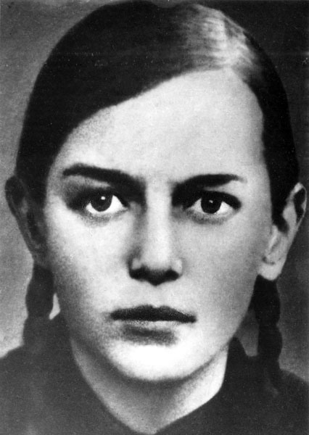

**Aleksandra Samusenko**

