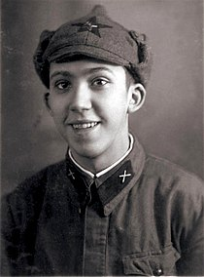
Yuri Vladimirovich Nikulin
(18 December 1921 – 21 August 1997)

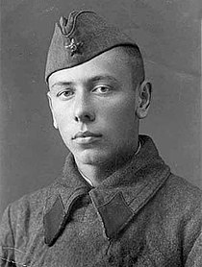
Anatoli Dmitrievich Papanov
( 31 October 1922 — 5 August 1987)

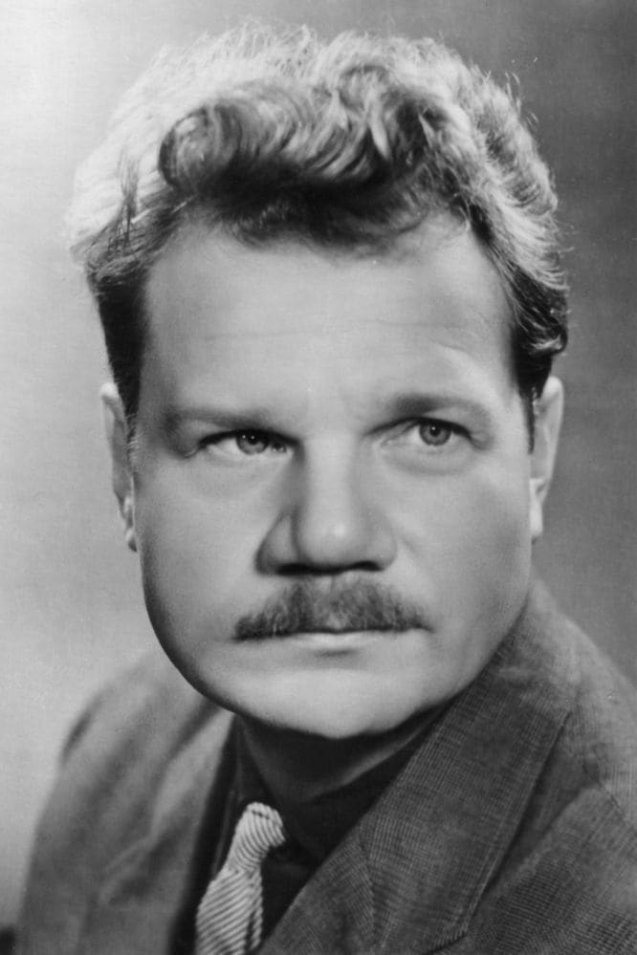
Mikhail Ivanovich Pugovkin
( 13 July 1923 — 25 July 2008)
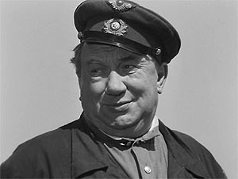
Aleksei Makarovich Smirnov
( 28 February 1920 – 7 May 1979 )
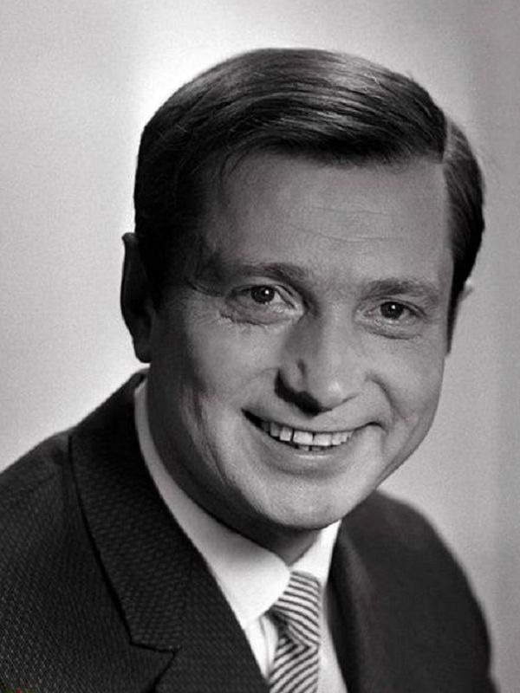

Vladimir Leonidovich Gulyaev
(30 October 1924-2 November 1997)
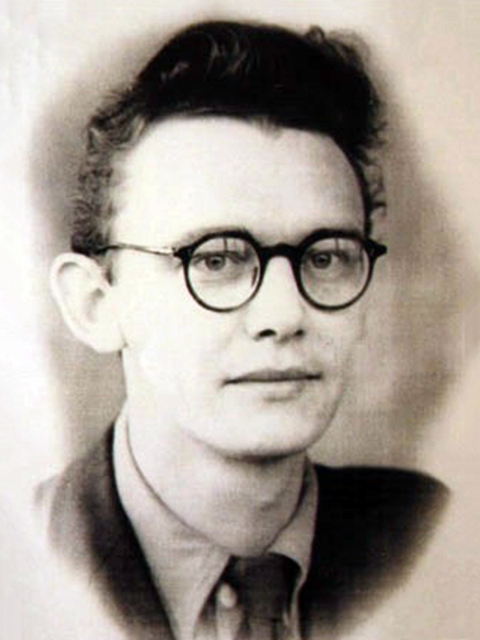
Leonid Iovich Gaidai
(30 January 1923-19 November 1997)

